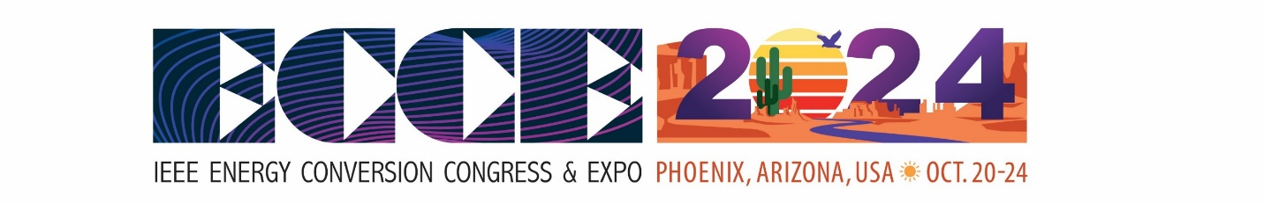
The Energy Conversion Congress and Exposition (ECCE) typically attracts a diverse range of industry professionals, researchers, academics, and experts in the field of energy conversion. ECCE covers a broad spectrum of topics related to energy conversion technologies, systems, and applications. The professionals you might encounter at ECCE 2024 could include:
- Researchers and Academics:
  - Scientists and academics involved in research related to energy conversion technologies.
- Engineers:
  - Professionals specializing in electrical, electronic, mechanical, or power engineering.
- Industry Leaders and Executives:
  - Decision-makers and executives from companies involved in energy conversion, power electronics, renewable energy, and related industries.
- Practitioners:
  - Engineers and professionals actively involved in the design, development, and implementation of energy conversion systems.
- Policy Makers:
  - Government officials and policymakers involved in shaping energy policies and regulations.
- Consultants:
  - Energy consultants providing expertise in the optimization and implementation of energy conversion solutions.
- Students:
  - Graduate and undergraduate students pursuing studies in fields related to energy conversion.
- Entrepreneurs and Innovators:
  - Individuals and companies working on innovative technologies and solutions in the energy conversion sector.
- Manufacturers and Suppliers:
  - Representatives from companies involved in the manufacturing and supply of components, materials, and equipment related to energy conversion.
- Utilities and Energy Service Providers:
  - Professionals from utility companies and energy service providers exploring or implementing energy conversion solutions.
The ECCE event provides a platform for networking, knowledge exchange, and collaboration among professionals in the energy conversion industry. The specific individuals you may meet will depend on your area of interest within the broader field of energy conversion and the focus of the event in a given year. Click here to download the attendees list from ECCE 2023.

